**SmartDoc**

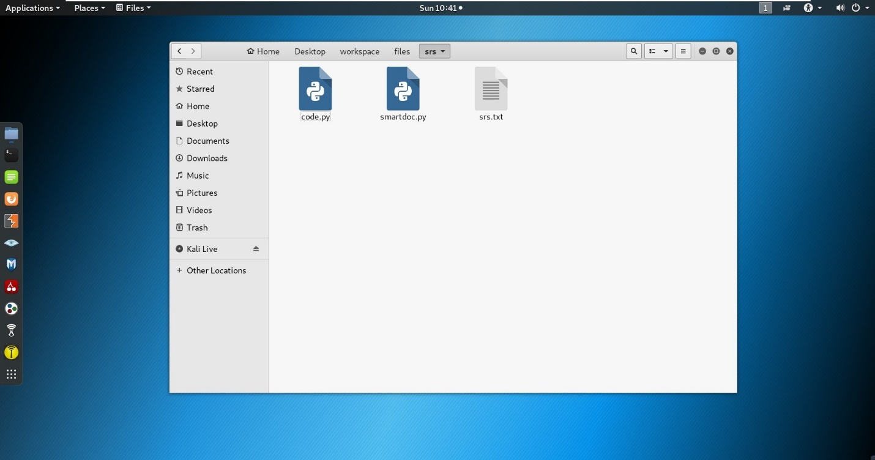

Firstly, use the pwd command to check if you’re in the root directory and then use the ls command to list all the files in the root directory as shown below.

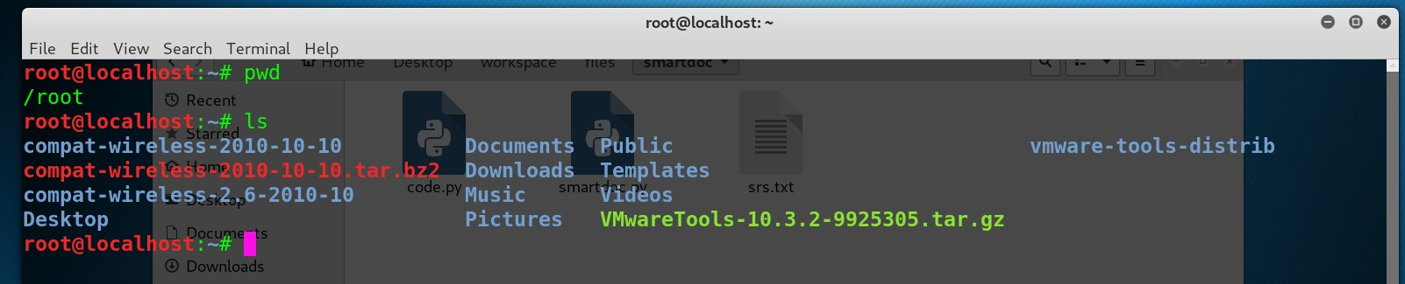

Navigate to the program directory as shown in the picture below.

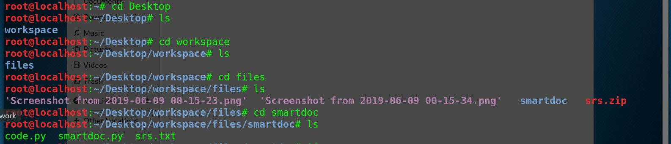

Open the folder containing the 3 files you open a terminal window and execute the script via python3 [smartdoc.py as shown in the image below and it should generate the output files.](https://www.freelancer.com/users/l.php?url=http:%2F%2Fsmartdoc.py&sig=7382a8dcf256de8c6fa61b5b20a2c0e3c46adbb0c15a1f8a462ffe7afad871f4" \t "_blank)

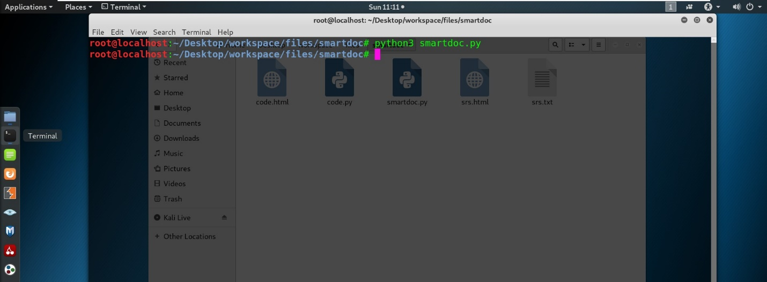

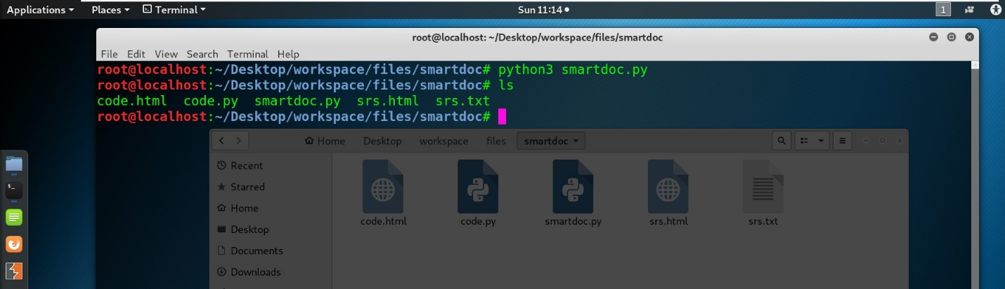

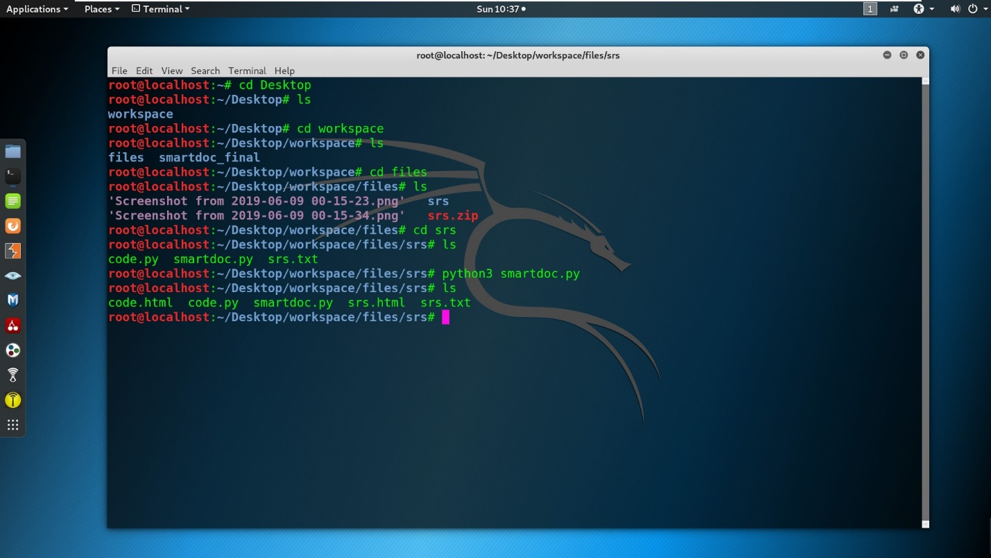

Basically what this program is doing is opening a [code.py and a srs.txt files that are located in the same directory and searching for all tags that are in the form of { see x } and the [id = X ] Then it will automatically start generating links to each other you can add other tags and run the script and it will generates the links.](https://www.freelancer.com/users/l.php?url=http:%2F%2Fcode.py&sig=d2f7ba54a810606f20d386f236af6e5ab44d17dc99e06af93b10a7e6f2f5260f" \t "_blank)

